import pandas as pd

from sklearn.model_selection import train_test_split

from sklearn.linear_model import LogisticRegression

from sklearn.metrics import accuracy_score

data = {'CustomerID': [1, 2, 3, 4, 5, 6, 7, 8],

'MonthlyCharges': [20, 65, 40, 75, 30, 80, 55, 90],

'Tenure': [12, 5, 24, 3, 18, 7, 30, 1],

'Churn': [0, 1, 0, 1, 0, 1, 0, 1]} # 0: No Churn, 1: Churn

df = pd.DataFrame(data)

X = df[['MonthlyCharges', 'Tenure']]

y = df['Churn']

X_train, X_test, y_train, y_test = train_test_split(X, y, test_size=0.3, random_state=42)

model = LogisticRegression()

model.fit(X_train, y_train)

y_pred = model.predict(X_test)

accuracy = accuracy_score(y_test, y_pred)

print(f"Model Accuracy: {accuracy:.2f}")

new_customers = pd.DataFrame({'MonthlyCharges': [45, 85], 'Tenure': [10, 2]})

predictions = model.predict(new_customers)

print("\nChurn Predictions for New Customers:")

for i, pred in enumerate(predictions):

print(f"Customer {i+1}: {'Churn' if pred == 1 else 'No Churn'}")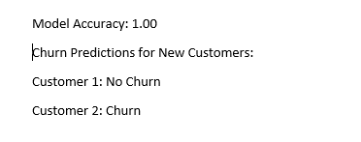

**OUTPUT**